# Setup Guide: Custom Files Component (v1.0)

In this document are detailed the steps to set up the required environment in a Salesforce organization, in order to use the *Lightning Web Component* called *Custom Files* (in its version 1.0) properly, having a correct behavior and performance. For using this component in the current version, the only previous requirement is to manually create a *custom field* in the *Content Version* *standard* *object* of the Salesforce organization.

## Create Custom Field in Content Version Standard Object

The *Custom Field* required for this *Lightning Web Component* to work is called *Category.* In this field a user can specify a desired category to the attachment (e. g. contract, letter, proposal, quotation, etc). Following are the list of ordered steps to create this field in the Salesforce organization using the *Salesforce Lightning[1]* interface.

1. From the Home Page of the Salesforce org, click the gear icon on the upper right corner of the screen and select ‘**Setup**’from the drop down menu.

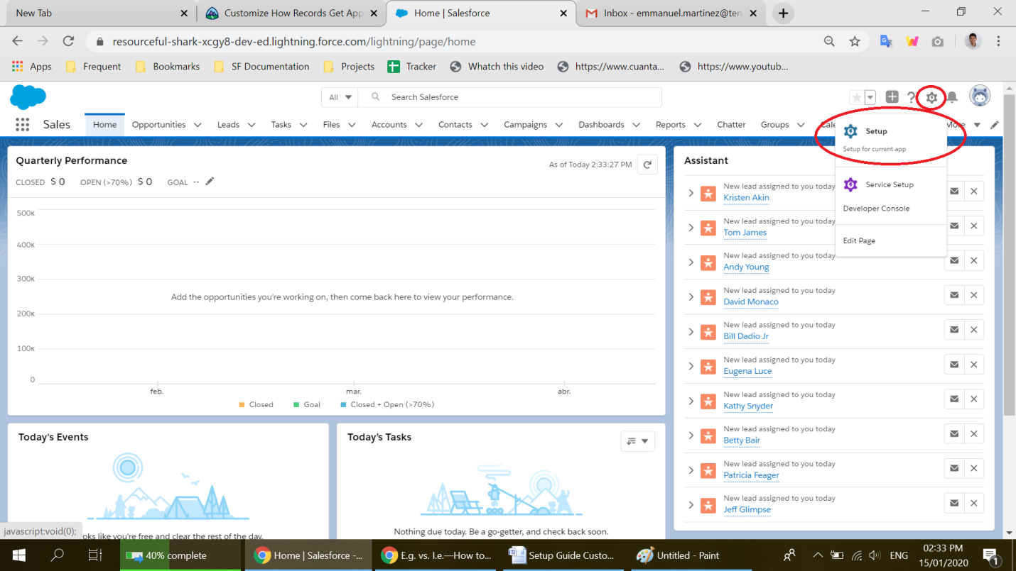

1. From the upper side of the menu, click on ‘**Object Manager**’

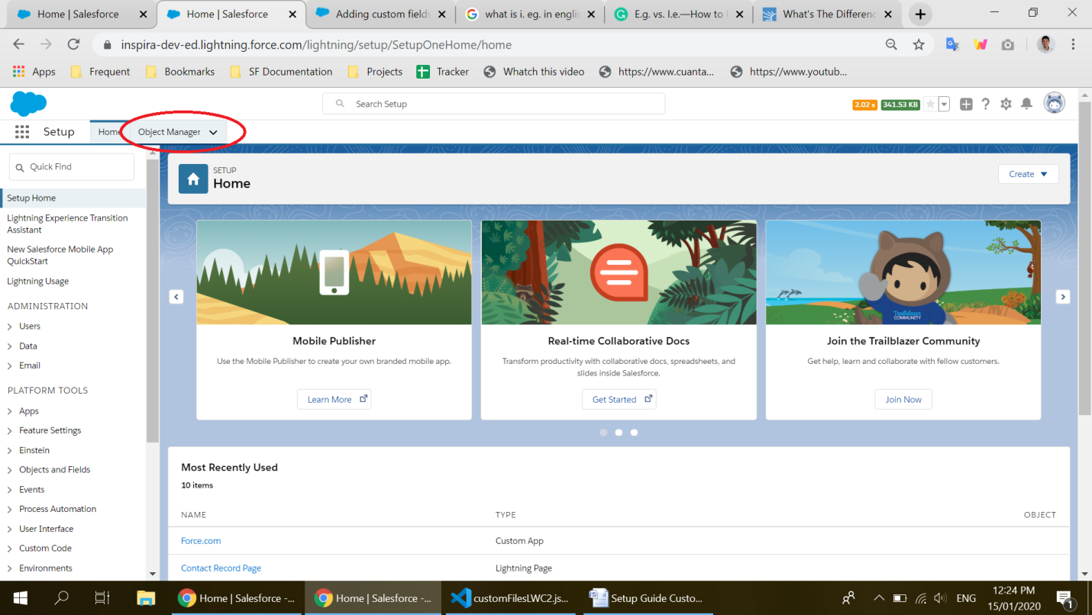

1. In the search bar at the top of the menu search for the keyword ‘**Content’,** and from the list of elements displayed click on ‘**Content Version’**.

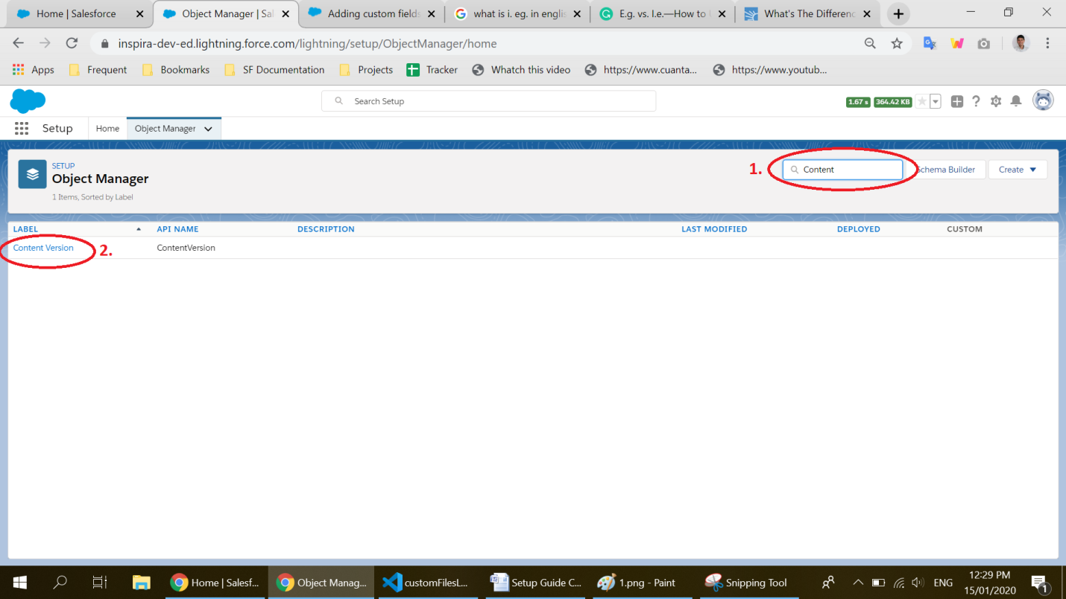

1. In the list of options at the left side of the screen click on ‘**Fields and Relationships**’

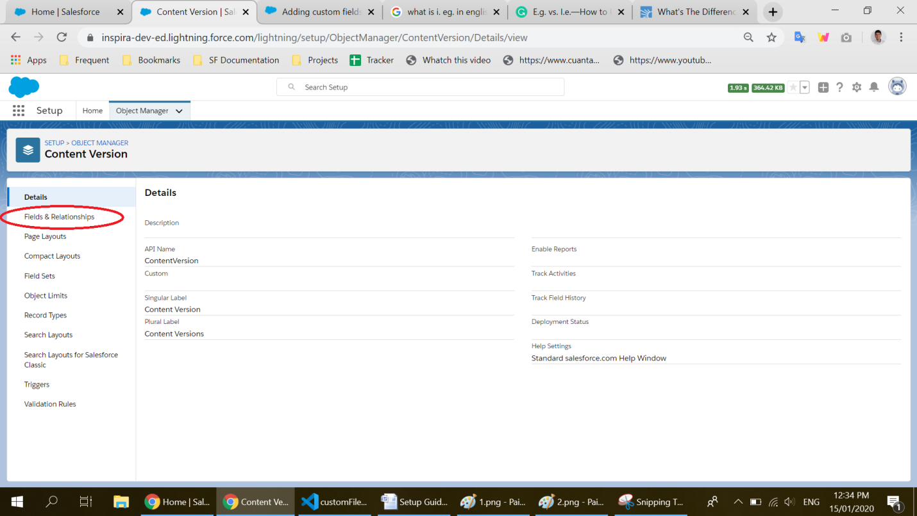

1. Click on ‘**New**’ at the upper side of the screen.

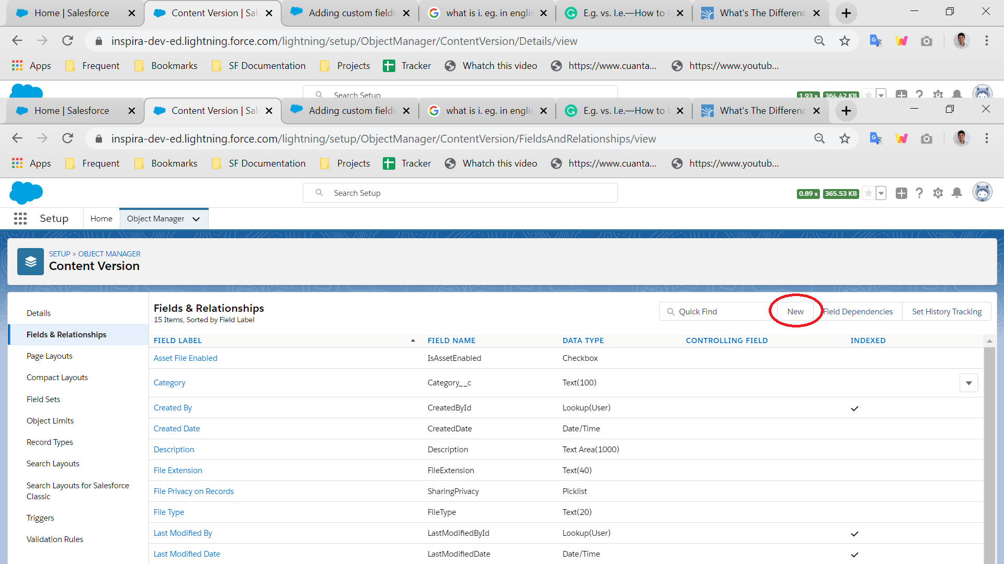

1. In the ‘field type’ menu that is displayed, select ‘**Text**’ from the list of options, near to the end.

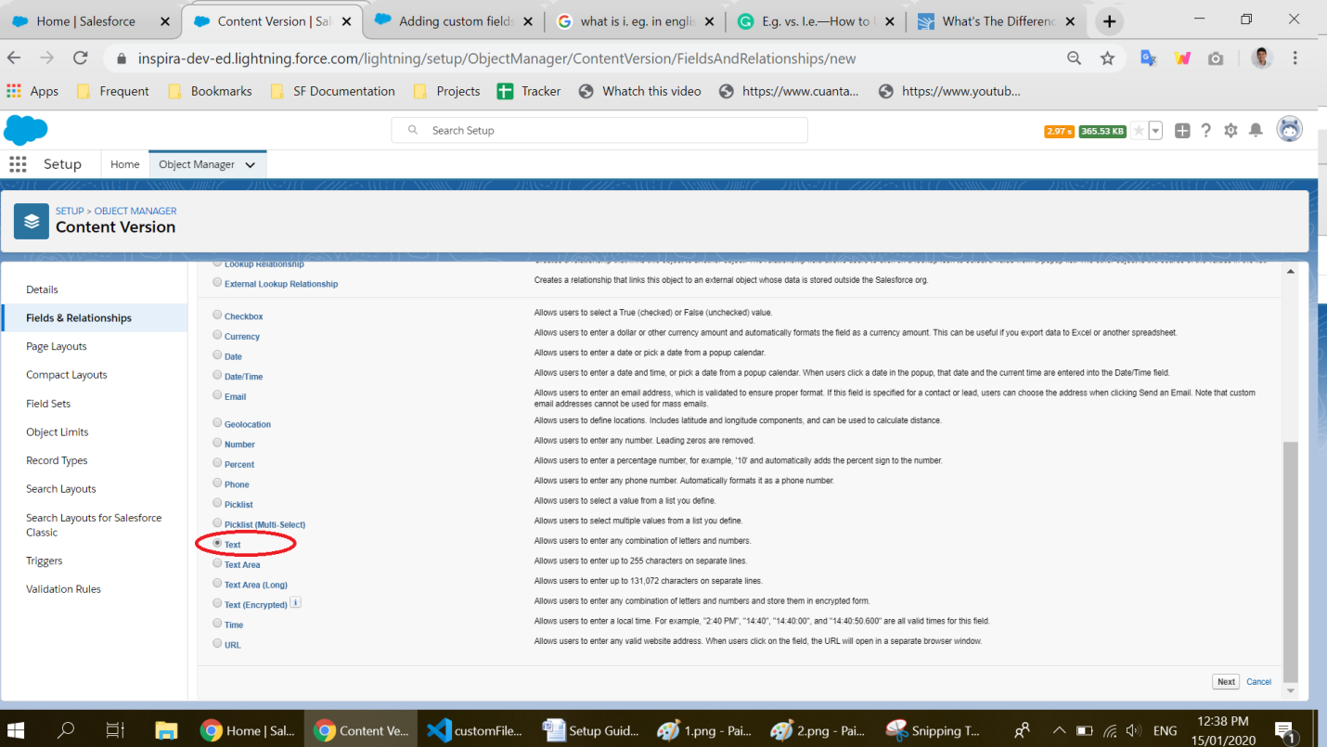

1. Fill the information in the new screen that appears like is shown in the below image. In **‘Field label**’ write ‘**Category’** with a capital ‘C’ letter. In ‘**Length’** write the number 100. The ‘**Field Name**’ field should be automatically filled, if it doesn’t, write on it ‘Category’ again, also with capital ‘C’ letter

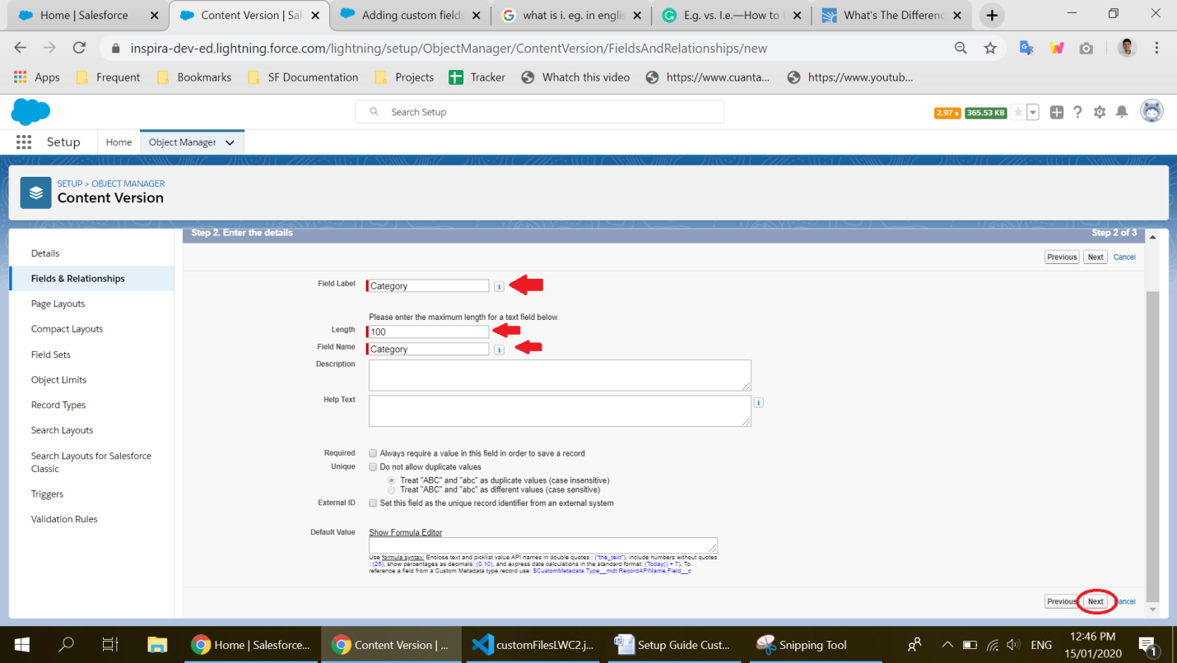

1. In the next screen click on **‘Save’**

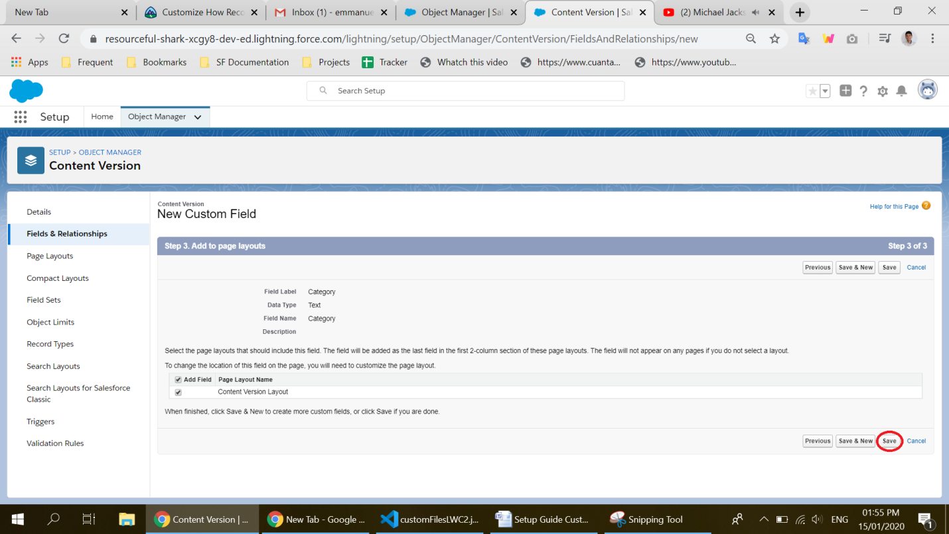

## Usage of the component

This component is intended **to be used only in *record-detail* pages**, preferably in the related list section of the page. To modify the related files associated with a record, this component needs to access the current record ID to know what files should it load and handle. Therefore, the component needs to be added to a record-detail page because only pages of this kind can give the required ID to the component to work.

Now that everything has been configured, the component can be added to the record-detail page of the Contact, Account or Opportunity objects, as well as any Custom object created that has related files. It can be easily drag-and-dropped from the editor of the page to the location of preference.

For more information about adding *Lightning Web Components* to pages please refer to [this article](https://salesforce.stackexchange.com/questions/63950/is-there-any-way-to-add-lightning-component-to-a-page-layout)[2]

1. *Salesforce Lightning* interface is an enhanced user interface designed by salesforce to interact with its functionality, and is the successor of the prior user interface, commonly known as *Salesforce Classic.*
2. The article referred is not part of the official Salesforce documentation although gives detailed instruction in how to add the component to a desired *record-detail* page.